**VEER NARMAD SOUTH GUJARAT UNIVERSITY**

**SURAT**

J. P. DAWAR INSTITUTE OF INFORMATION

SCIENCE & TECHNOLOGY

M.Sc. (Information Communication Technology)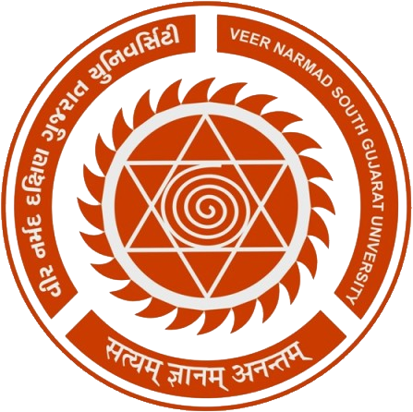

**3rd** Semester

M.Sc. (Information Communication Technology)

Year 20**19**-20**20**

PROJECT REPORT

ON

**“Online Education System”**

**GUIDED BY:** **SUBMITTED BY:**

Ms. Krishna Desai Sonar Tushar B.(10046)

**Prakshal IT Infotech**

Gulab Baba Mill Compound, Near Railway Station, Lal Darwaja, Surat – 395003

**Veer Narmad South Gujarat University, Surat.**

**M.Sc. (Information Communication Technology)**

**Certificate**

This is to certify that **Mr. Sonar Tushar B. (Exam No**: **10046)** has satisfactorily completed her project work entitled **“Online Education System”** as a partial fulfilment of the Requirements for **3rd Semester - M. Sc. (Information & Communication Technology)**, during the academic Year 20**18**-20**19**.

**Co-Ordinator**

**Date: December, 2019 M.Sc. (I.C.T) Programme.**

**Place: Surat VNSGU, SURAT**